 |  |  |  | What you need to know about your flexible partial
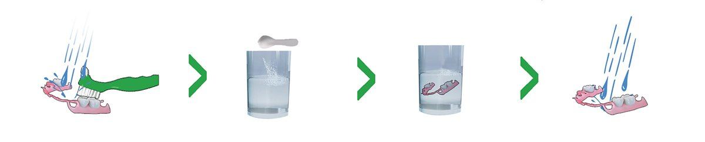

In order to keep them looking and feeling like new, please follow these simple recommendations:
- Continue to brush your natural teeth and gums as directed by your dentist.
- Clean your appliance daily. Rinse under warm running water for approximately 10-30 seconds to remove any food particles.
- Brush your appliance with a soft denture brush using water only. Rinse again.
- Place your appliance in a denture cleaner for at least 15 minutes daily. When possible, keep your appliance in water or a denture solution when you are not wearing it.
DO NOT use bleach, toothpaste, or similar cleaning products, these may scratch or discolor the surface of your appliance

3613 Richardson Square Dr.
Suite 100
Arnold, MO 63010
 |  | 636-461-0093
 |  | info@reutherdental.com
 |  | www.ReutherFamilyDental.com

